Part 1:

MATLAB Program:

1.

2. Let be 0.

3.

4.

Part 2:

MATLAB Program:

1.

Let and $y^{'}\left(0\right)$ be 0.

$LCs^{2}Y\left(S\right)+RCsY\left(s\right)+Y\left(s\right)=X\left(s\right)$ $\left(LCs^{2}+RCs+1\right)Y\left(s\right)=X\left(s\right)$

$H\left(s\right)=\frac{Y\left(s\right)}{X\left(s\right)}=\frac{1}{LCs^{2}+RCs+1}$ $=\frac{1}{\left(\left(10*{10}^{-3}\right)\left({10}^{-6} \right)\right)+\left({10}^{-6}\right)Rs+1}=\frac{1}{{10}^{-8}s^{2}+R*{10}^{-6}s+1}$

2.

|  |  |
| --- | --- |
| R Value ($Ω$) | Roots |
| $$50$$ | $$1000\left(-2.5±j9.6825\right)$$ |
| $$10$$ | $$1000(-0.5±j9.9875)$$ |
| $$1$$ | $$1000\left(-0.05±j9.9991\right)$$ |
| $$0.5$$ | $$1000\left(-0.025±j10.0000\right)$$ |
| $$0$$ | $$±j10000$$ |



Decreasing the resistance decreases system stability.

3.

:

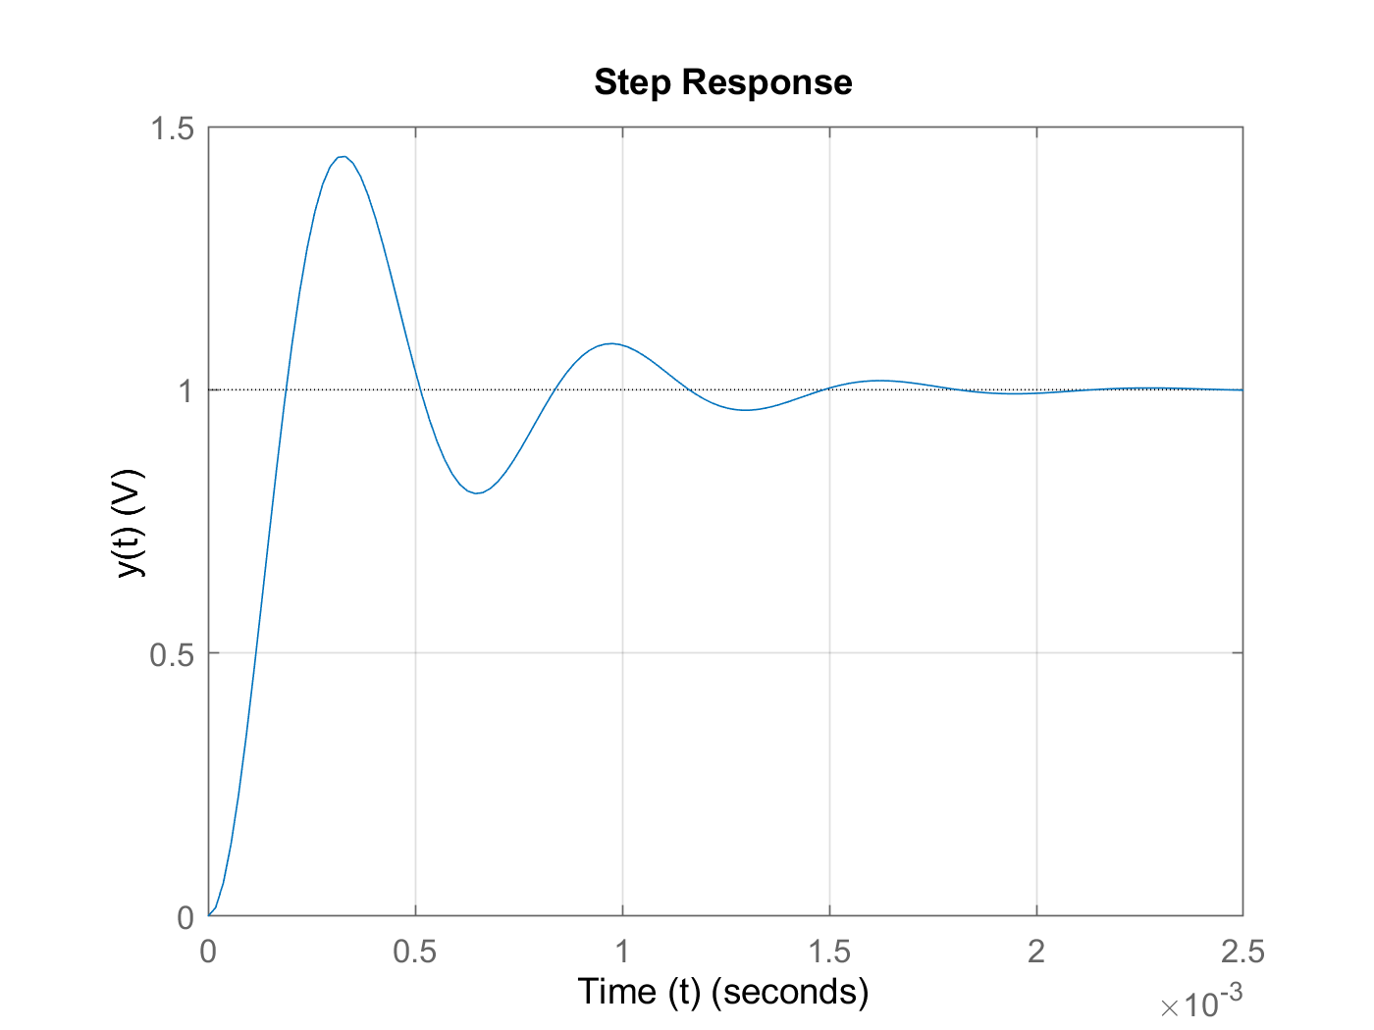

:

:

:

:

4. The further away from the complex axis (imaginary part = 0), the faster the signal dampens. When the poles are on the complex axis, the output oscillates permanently.

5.

Poles:

The system becomes unstable with negative resistance, with the magnitude of oscillation increasing infinitely.